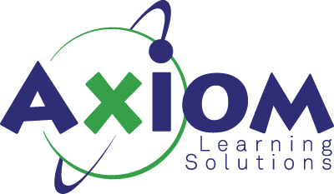

AWS Well-Architected Best Practices Workshop
Course Length: 1 Day
Course Structure:
Introduction & Framework Overview
- AWS Well-Architected Framework purpose and history
- The six pillars at a glance
- How to use the Well-Architected Tool in the console
Pillar 1: Operational Excellence
- Design principles: operations as code, small reversible changes, anticipate failure
- Observability: CloudWatch, X-Ray, CloudTrail integration
- Runbooks and playbooks for incident response
- Infrastructure as Code with CloudFormation/CDK
- Discussion: real-world operational debt scenarios
Pillar 2: Security
- Identity and access management (IAM policies, roles, least privilege)
- Detective controls: GuardDuty, Security Hub, Config rules
- Infrastructure protection: VPCs, security groups, WAF
- Data protection: encryption at rest (KMS) and in transit (TLS)
- Incident response preparation
- Lab exercise: reviewing an IAM policy for least privilege violations
Pillar 3: Reliability
- Foundations: service quotas, network topology planning
- Change management: monitoring, auto-scaling triggers
- Failure management: fault isolation, backup/recovery strategies
- Multi-AZ vs. multi-region architectures
- RTO/RPO planning and disaster recovery patterns
- Case study: designing for a regional outage
Pillar 4: Performance Efficiency
- Selection: choosing the right compute, storage, database, and network options
- Review: benchmarking and load testing approaches
- Monitoring: identifying bottlenecks with CloudWatch and Performance Insights
- Trade-offs: caching strategies, read replicas, CDN usage
- Discussion: when to use serverless vs. containers vs. EC2
Pillar 5: Cost Optimization
- Expenditure awareness: Cost Explorer, Budgets, tagging strategies
- Cost-effective resources: Savings Plans, Reserved Instances, Spot
- Right-sizing with Compute Optimizer
- Matching supply and demand: auto-scaling, scheduling
- Exercise: analyzing a sample cost allocation report
Pillar 6: Sustainability
- Understanding the shared responsibility model for sustainability
- Region selection and efficient resource utilization
- Managed services and their sustainability benefits
- Data management: tiering, lifecycle policies, deduplication
- Software and architecture patterns that reduce environmental impact
Practical Application & Wrap-Up
- Conducting a Well-Architected Review: walkthrough of the tool
- Prioritizing findings: high-risk items vs. improvement opportunities
- Building a remediation roadmap
- Integrating reviews into your SDLC
- Q&A and discussion

